**2. Materials and Methods**

2.1 Study System

We selected study sites on the Pike National Forest in the foothills of central Colorado outside Pine, CO. The forest here is characterized by ponderosa pine (*Pinus ponderosa*) and intermixed lodgepole (*Pinus contorta*) and Douglas-fir (*Pseudotsuga menziesii*). This area experienced two mixed-severity wildfires, the 11,690 acre Buffalo Creek (1996) and 9,607 acre High Meadows (2001) fires, that resulted in a matrix of burn severities. Using standardized Monitoring Trends in Burn Severity (hereafter MTBS) difference normalized burn severity (dNBR) data that we also ground-truthed, we established three 50x50m (0.25 ha) sites per burn severity (unburned, low, high) per fire for a total of 18 sites. We ground-truthed stand fire severity by measuring canopy cover, as well as observing evidence of past fire such as charring on logs, stumps, live trees, and snags. We considered stands with no canopy cover besides small regrowth to be high severity and low burn stands as stands within the fire boundary with evidence of fire but with little impacts on the overstory canopy. Unburned sites were established in stands outside of the known focal fire boundaries and any other existing fires using MTBS geographic data. We also attempted to avoid areas that had been thinned by observing the presence of cut stumps. We established our 50x50m sites by selectively locating a suitable representative stand, and then walking 50m along a random compass azimuth to establish our site center. We also considered accessibility along roads and trails when selecting our sites.

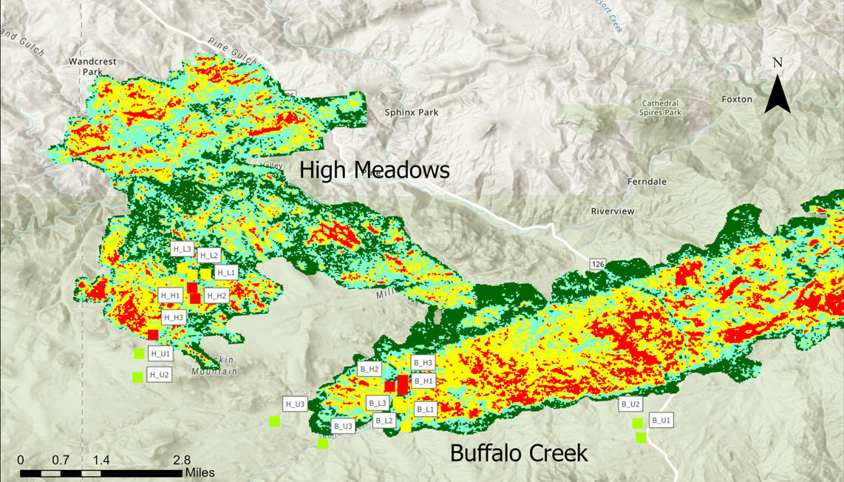

**Figure 1:** Map of our 18 site locations across both fires. Fire boundaries are shown with MTBS dNBR data. High severity locations are indicated in red, moderate in yellow, and low in teal, and low-to-unburned in green. For our purposes, we considered high and moderate sites as high severity, low and low-to-unburned as low severity as long as there was visual evidence of fire.

(should I include my ArcGIS map of my sites with the burn severity map?? Rough draft of it above, can make it black and white/easier to read or less busy)

We surveyed both available floral resources and the bee community across all sites from snowmelt (early April) to the end of the main growing season (late August). While some bees may be active in early March, snow and forest road accessibility limited our study period. We sampled both floral resources and bees bi-monthly, and both were sampled on the same day for each site when possible. Weather and time were limiting factors as cloudy, windy, or cold conditions negatively impact both blooming flowers and bee activity. We only surveyed between the times of 1000 and 1430 each day, and only when the temperature was above freezing (0 ◦C), wind gusts and sustained winds were below 20 mph, and cloud cover was below 60%.

2.2 Bee surveys and plant-pollinator interactions

We collected bee specimens in the field using targeted netting of bees actively foraging on flowering plants. We surveyed the entire 50x50m plot by meandering between floral patches for a period of 30 minutes. Time was paused for removal of captured bees from the net. We also recorded each floral species that we captured bees on to construct a plant-bee interaction network for our sites. To evaluate the abundance of these floral species, we centered a 70cm circular quadrat around the focal plant (the plant we captured the bee on) and recorded the cover class of that species and each additional flowering species within the quadrat using the DAFOR scale (citation?). The DAFOR scale uses visual evaluation to rank species cover into categorical classes (dominant, abundant, frequent, occasional, rare). If the bee was foraging on a woody shrub, we considered the abundance of that shrub to be the whole site count for that species as described below in our floral resource sampling.

2.3 Floral resource sampling

We measured floral resources, defined as currently blooming plants, along two 50m transects, one running north-south, the other east-west through the center of our sites. Every 5m along these transects, we sampled flowering herbaceous cover for each floral species in a 70 cm diameter circular quadrat using the DAFOR scale. For flowering woody shrubs over 20 cm tall, we recorded all individuals with open inflorescence across the entire 50x50m plot. We measured shrubs separately from flowering herbaceous ground cover because of their sparsely dispersed growth habit and larger diameter, making small quadrats impractical. Our herbaceous quadrats and whole plot shrub measurements allowed us to record the general floral diversity and abundance across burn severities.

2.4 Statistical Analyses

To analyze both bee community composition and floral resource availability, we used R programming language (R Core Team, 2022) and the vegan package (Oksanen et al.,2022).To analyze the effects of fire severity on bee abundance, species diversity (Shannon-Wiener index), and species richness, we ran two-way ANOVAs with an interaction effect on the effects of burn severity and fire identity (Buffalo Creek or High Meadows) on all of the bee variables (abundance, diversity, richness). For floral resource richness, we created a species list for each site both from the general 50m floral transects and from the flowers we collected bees from. We did this to create a more comprehensive species list for our sites because we expected to encounter species in the whole plot bee sampling that might not have been present along our transects. Floral abundance, however, was calculated only from the DAFOR cover classes along our floral transects. This is because we did not want to bias our measurements of floral abundance with an overemphasis on plants that were attractive to foraging bees from the bee sampling data.

For bee community composition, we used the vegan package (Oksanen et al., 2022) to run Non-metric Multidimensional Scaling (NMDS) to compare the species composition of unburned, low, and high severity sites. We ran all NMDS analyses with the metaMDS function on rank order Bray-Curtis dissimilarity distances, and determined significance with PERMANOVA analyses using the adonis function.

(Paragraph about plant-pollinator networks).